STROKE RISK PREDICTION

Name -Gopika.M

Under the guidence of:

Vishnu .A M


Department Of Health Tech AI&Data science

2025

INDEX
Sl. No | Contents | Page No
1 | Abstract | 1
2 | Introduction | 2
3 | Problem Statement | 3
4 | Objective of the Project | 4
5 | Project Idea / Concept | 5
6 | Dataset Description | 6
7 | System Methodology | 7
8 | Machine Learning Algorithms Used | 8
9 | Frontend Implementation | 10
10 | Power BI Dashboard Implementation | 11
11 | System Working Procedure | 12
12 | Model Evaluation and Validation | 13
13 | Result and Analysis | 14
14 | Advantages of the Proposed System | 15
15 | Future Scope | 16
16 | Real-Time Applicability | 17
17 | Conclusion | 18
18 | Technology Stack Summary | 19
19 | References | 20
Top of Form

Bottom of Form

STROKE RISK PREDICTION USING MACHINE LEARNING

1. ABSTRACT
Stroke is one of the leading causes of death and disability worldwide. Early prediction of stroke risk can help healthcare professionals provide timely treatment and preventive care. The main objective of this project is to develop a machine learning-based system capable of predicting whether a patient is at risk of stroke based on healthcare parameters.
The system uses healthcare datasets containing patient information such as age, gender, hypertension, heart disease, BMI, glucose level, smoking status, and other medical details. Data preprocessing techniques such as missing value handling, encoding, and feature selection are applied before training the machine learning models.
Several machine learning algorithms including Logistic Regression, Decision Tree, Random Forest, and Support Vector Machine (SVM) are used for prediction and performance comparison. The model is integrated with a streamlit frontend application for user interaction and a Power BI dashboard for visualization and analysis.
The proposed system provides fast and accurate stroke risk prediction and can support hospitals, healthcare centers, and telemedicine applications in improving healthcare decision-making.

2. INTRODUCTION
Machine Learning plays an important role in modern healthcare systems by enabling predictive analysis and intelligent diagnosis support. Stroke is a serious medical condition caused by interruption of blood supply to the brain. If not identified early, stroke can lead to paralysis, permanent disability, or death.
Traditional healthcare diagnosis methods mainly depend on manual observation and medical expertise. These methods may take more time and may not always provide accurate early predictions. With the growth of healthcare data, machine learning techniques can be used to build predictive systems capable of identifying disease risks efficiently.
This project focuses on developing a Stroke Risk Prediction System using Machine Learning techniques. The system analyzes patient health records and predicts the probability of stroke occurrence. The project combines data preprocessing, exploratory data analysis, machine learning algorithms, frontend development, and dashboard visualization to create a complete healthcare analytics solution.
The Streamlit application allows users to upload healthcare data and receive instant predictions. Power BI dashboards provide visual insights into healthcare trends and patient risk analysis.

3. PROBLEM STATEMENT
Stroke-related diseases are increasing rapidly due to unhealthy lifestyles, obesity, smoking, stress, diabetes, and hypertension. Early diagnosis of stroke risk is essential for reducing mortality rates and improving patient treatment.
Existing healthcare systems face several challenges:
- Lack of intelligent stroke prediction systems
- Delayed diagnosis and treatment
- Difficulty in analyzing large healthcare datasets manually
- Inaccurate or slow prediction methods
- Limited access to real-time healthcare monitoring systems
Therefore, there is a need for an automated and intelligent system capable of predicting stroke risk accurately using machine learning techniques.

4. OBJECTIVE OF THE PROJECT
The main objectives of the project are:
- To develop a machine learning model for stroke risk prediction
- To analyze healthcare datasets effectively
- To preprocess medical data and handle missing values
- To compare multiple machine learning algorithms
- To build a user-friendly frontend using Streamlit
- To visualize healthcare insights using Power BI dashboards
- To improve prediction accuracy and healthcare decision-making
- To provide early stroke risk detection support

5. PROJECT IDEA / CONCEPT
The project aims to create an intelligent healthcare system that predicts stroke risk using patient medical information.

Project Workflow:
- Collect healthcare stroke dataset
- Preprocess the dataset
- Perform Exploratory Data Analysis (EDA)
- Train machine learning models
- Evaluate model performance
- Develop Streamlit frontend application
- Create Power BI dashboard
- Generate predictions and visual reports
The system predicts whether a patient is at “High Risk” or “Low Risk” of stroke.

6. DATASET DESCRIPTION
The dataset used for this project is a healthcare stroke dataset containing patient demographic and medical information.

Dataset Features
Feature | Description
Gender | Male/Female
Age | Patient age
Hypertension | Blood pressure condition
Heart Disease | Presence of heart disease
Ever Married | Marital status
Work Type | Employment type
Residence Type | Urban/Rural
Avg Glucose Level | Blood glucose level
BMI | Body Mass Index
Smoking Status | Smoking habits
Stroke | Target variable

Target Variable
- 0 → Low Risk
- 1 → High Risk

Data Preprocessing
The following preprocessing steps were applied:
- Handling missing values using Simple Imputer
- Converting categorical values into numerical format
- Removing duplicate values
- Feature selection and transformation
- Splitting dataset into training and testing data

7. SYSTEM METHODOLOGY
The methodology of the project follows a machine learning pipeline.

Step 1: Data Collection
Healthcare stroke dataset collected from public sources.

Step 2: Data Preprocessing
- Handle missing values
- Encode categorical data
- Clean inconsistent records

Step 3: Exploratory Data Analysis
EDA techniques include:
- Bar charts
- Histograms
- Correlation heatmaps
- Pie charts
- Distribution analysis

Step 4: Model Training
Train multiple machine learning algorithms.
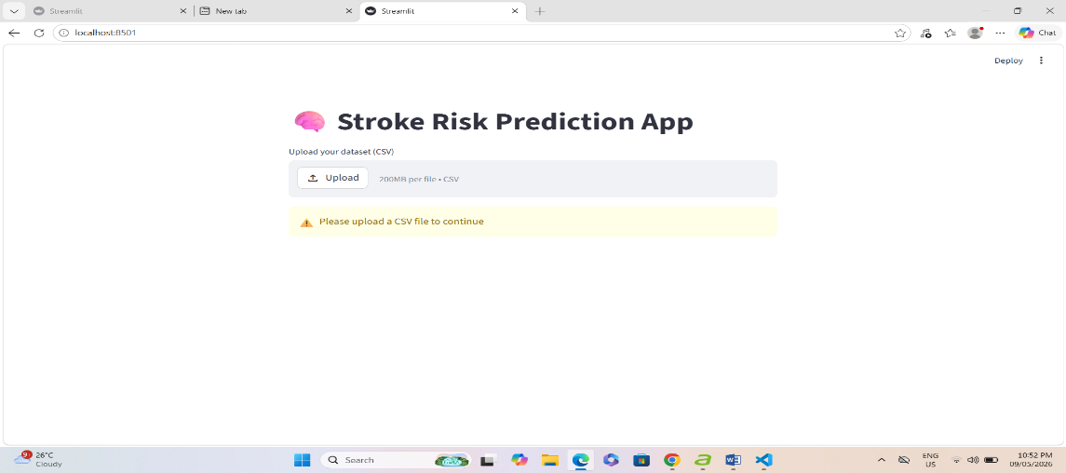
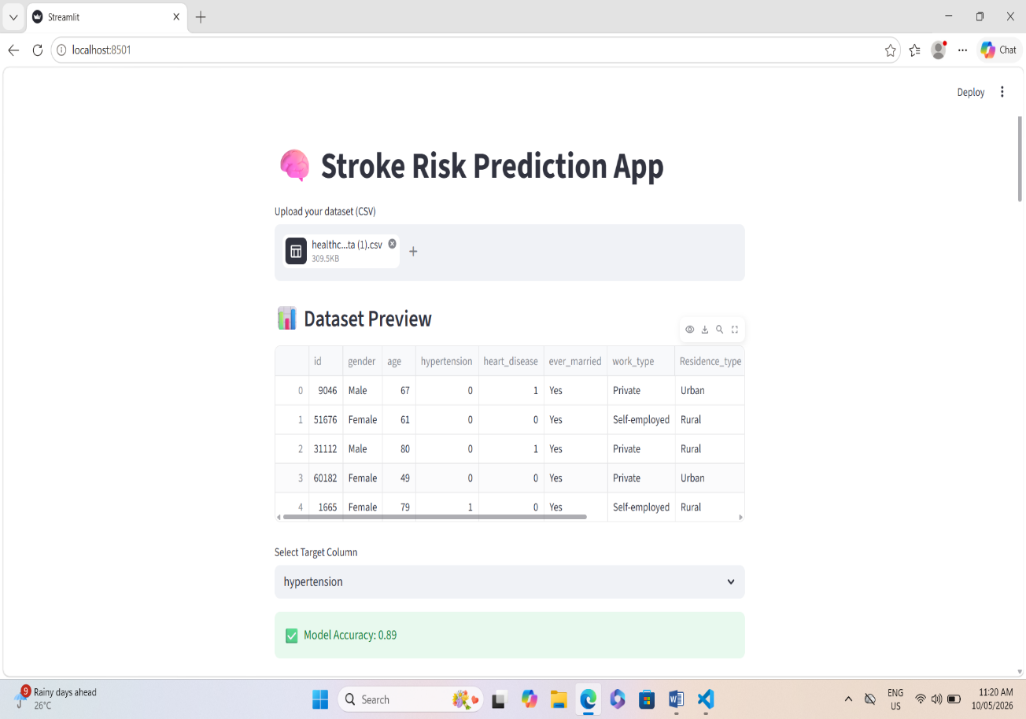

Step 5: Model Evaluation
Evaluate models using accuracy and performance metrics.

Step 6: Frontend Development
Develop interactive Streamlit application.

Step 7: Dashboard Visualization
Create Power BI dashboard for healthcare analytics.

8. MACHINE LEARNING ALGORITHMS USED

1. Logistic Regression
Logistic Regression is used for binary classification problems. It predicts whether a patient belongs to the high-risk or low-risk category.

Advantages:
- Simple and fast
- Good for binary classification
- Easy interpretation

2. Decision Tree
Decision Tree creates prediction rules based on dataset attributes.

Advantages:
- Easy visualization
- Handles nonlinear relationships

3. Random Forest
Random Forest combines multiple decision trees to improve prediction accuracy.

Advantages:
- High accuracy
- Reduces overfitting
- Robust model performance

4. Support Vector Machine (SVM)
SVM separates classes using optimal hyperplanes.

Advantages:
- Effective in high-dimensional data
- Good classification performance

9. FRONTEND IMPLEMENTATION
The frontend application was developed using the Streamlit framework.

Frontend Features
- CSV dataset upload
- Dataset preview
- Target column selection
- Model training
- Accuracy visualization
- User input form
- Real-time prediction

Technologies Used
- Python
- Pandas
- NumPy
- Matplotlib
- Scikit-learn
- Streamlit

Prediction Output
The system displays:
- High Risk
- Low Risk
based on patient health information.

10. POWER BI DASHBOARD IMPLEMENTATION
Microsoft Power BI was used to create interactive healthcare dashboards.

Dashboard Components
- Age-wise stroke analysis
- Gender comparison
- Smoking status visualization
- BMI analysis
- Glucose level charts
- High-risk patient statistics

Advantages of Power BI
- Interactive visualization
- Better healthcare insights
- Easy reporting
- Real-time data analysis

11. SYSTEM WORKING PROCEDURE
The complete working process is as follows:
- User uploads healthcare dataset
- System reads dataset using Pandas
- Data preprocessing is applied
- Missing values are handled
- Features are encoded
- Dataset is split into training/testing data
- Machine learning model is trained
- Accuracy is calculated
- User enters patient details
- Model predicts stroke risk
- Result is displayed on Streamlit interface
- Power BI dashboard visualizes insights

12. MODEL EVALUATION AND VALIDATION
Model evaluation is essential to measure prediction performance.

Evaluation Metrics
Metric | Description
Accuracy | Overall prediction correctness
Precision | Accuracy of positive predictions
Recall | Ability to identify stroke cases
F1 Score | Balance between precision and recall

Validation Techniques
- Train-Test Split
- Cross Validation
- Confusion Matrix Analysis
The best-performing model was selected for deployment.

13. RESULT AND ANALYSIS
The machine learning models successfully predicted stroke risk with good accuracy.

Key Findings
- Age and glucose level strongly influence stroke occurrence
- Hypertension and BMI are important risk factors
- Data preprocessing improved accuracy
- Random Forest achieved better prediction performance
- Logistic Regression provided stable classification results
The Streamlit application generated real-time predictions, while Power BI dashboards provided detailed visual analysis.

14. ADVANTAGES OF THE PROPOSED SYSTEM
- Early stroke risk detection
- Faster prediction process
- User-friendly interface
- Accurate healthcare analytics
- Real-time prediction support
- Interactive visualization
- Reduced manual effort
- Better healthcare decision-making

15. FUTURE SCOPE
Future improvements may include:
- Cloud deployment
- Mobile application development
- Deep learning implementation
- Real-time patient monitoring
- IoT healthcare integration
- Multi-disease prediction
- AI recommendation systems
- Hospital database integration

16. REAL-TIME APPLICABILITY
The system can be used in:
- Hospitals
- Clinics
- Telemedicine systems
- Healthcare research centers
- Insurance risk analysis
- Preventive healthcare systems
- Smart healthcare applications
The project supports healthcare professionals in identifying high-risk patients early.

17. CONCLUSION
The “Stroke Risk Prediction Using Machine Learning” project demonstrates the importance of machine learning in healthcare analytics. The system successfully predicts stroke risk using healthcare data and supervised learning algorithms.
The project includes:
- Data preprocessing
- Exploratory analysis
- Machine learning model training
- Frontend development using Streamlit
- Dashboard visualization using Power BI
The system provides accurate predictions and supports intelligent healthcare decision-making. The project proves that AI and machine learning can improve medical diagnosis and preventive healthcare services.

18. TECHNOLOGY STACK SUMMARY
Category | Technology
Programming Language | Python
Libraries | Pandas, NumPy, Matplotlib, Scikit-learn
Frontend | Streamlit
Dashboard | Power BI
IDE | Jupyter Notebook, VS Code
Dataset Format | CSV
ML Algorithms | Logistic Regression, Random Forest, SVM, Decision Tree

19. REFERENCES
- Scikit-learn Official Documentation
- Streamlit Official Website
- Microsoft Power BI
- Pandas Documentation
- NumPy Documentation
- Matplotlib Documentation
- Kaggle healthcare stroke dataset
- Research papers on Machine Learning in Healthcare
- Python Official Website
- Articles related to healthcare analytics and stroke prediction systems.

